

GITAM Bengaluru Campus, NH 207, Nagadenahalli Doddaballapura

Taluk, Bengaluru Rural District-561203

“**Monostable Multivibrator**”

**Atigadda Madhankumar Chetty**

**2024099528**

**MTech in VLSI Design**

**Technical Seminar**

**GITAM University, Bangalore**

Table of Contents

1. Introduction: 5

2. Apparatus Used: 5

3. Working Principle: 5

4. State-of-the-Art: 6

2000-2010 8

2011-2020 9

2021-2025 10

5.My Requirement : 11

6. Circuit Implementation Details: 12

7.Testing & Results: 14

8. Cost Analysis: 15

9.Challeges Faced : 17

10. Applications: 17

11. Limitations: 17

12. Conclusion: 18

13.References: 18

# Table of Figures

Figure 1:Schematic of Monostable Multivibrator 12

Figure 2:Capacitor Output 14

Figure 3:Monostable Multivibrator Output 15

Figure 4:All Outputs 15

# List of Tables

Table 1:State-of-the-Art Monostable Multivibrators (2000-2025) 8

# 1. Introduction:

A monostable multivibrator, also known as a one-shot multivibrator, is an electronic circuit that generates a single output pulse of a predetermined duration when triggered. Unlike astable multivibrators, which produce a continuous train of pulses, the monostable circuit has only one stable state. When triggered, it transitions to an unstable state for a specific period and then returns to its stable state. This characteristic makes monostable multivibrators useful for various timing and pulse-shaping applications.

# 2. Apparatus Used:

* Simulation Software: LTSpice
* Components:
  + Operational Amplifier: LM741 (U1)
  + Resistors:
    - R1: 220kΩ
    - R2: 10kΩ
    - R3: 120kΩ
  + Capacitors:
    - C1: 0.027µF (27nF)
    - C2: 91pF
  + Diode: 1N4914 (D1)
  + Voltage Sources:
    - VCC: +12V
    - VEE: -12V

# 3. Working Principle:

The circuit operates based on the charging and discharging of capacitor C1 through resistor R3, controlled by the LM741 op-amp and the diode D1.

1. Stable State: In the stable state, the output of the op-amp is low (near VEE). Diode D1 is forward-biased, clamping the voltage at the inverting input of the op-amp to approximately one diode drop above VEE. Capacitor C1 is discharged.
2. Trigger Input: A positive pulse applied to Vin triggers the circuit. This pulse is coupled through C2 to the non-inverting input of the op-amp, causing the output to switch high (near VCC).
3. Unstable State: With the output high, diode D1 is reverse-biased. Capacitor C1 starts charging through R3 towards VCC. The voltage at the inverting input rises exponentially.
4. Timing Period: When the voltage at the inverting input exceeds the voltage at the non-inverting input (which is determined by the voltage divider formed by R1 and R2), the op-amp output switches back to the low state.
5. Return to Stable State: Diode D1 becomes forward-biased again, quickly discharging C1. The circuit returns to its stable state, ready for the next trigger.

The duration of the output pulse (unstable state) is determined by the time constant R3 * C1.

# 4. State-of-the-Art:

|  |  |  |  |  |  |  |
| --- | --- | --- | --- | --- | --- | --- |
| Product | Manufacturer | Year | Cost (USD) | Features | Advantages | Disadvantages |
| NE555 Monostable Timer | Texas Instruments | 2002 | $0.30 - $1.00 | Single-stable state with pulse width controlled by external capacitor and resistor. Low power consumption. Versatile usage in delay circuits and pulse generators. | Low cost, widely available, easy to use. | Limited precision due to external components, not suitable for high-frequency applications. |
| MC1455 Monostable Multivibrator | ON Semiconductor | 2005 | $2 - $5 | Improved stability and accuracy compared to NE555. Adjustable pulse width with external timing components. TTL and CMOS compatibility. | Improved precision, good noise immunity. | Requires external components for fine-tuning, slightly higher cost. |
| ADG3123 Precision Pulse Generator | Analog Devices | 2008 | $10 - $20 | High-precision monostable output. Low drift over temperature variations. Designed for industrial and military applications. | High reliability, precise timing. | Expensive, complex to integrate in basic circuits. |
| TLC555 CMOS Monostable Timer | Texas Instruments | 2013 | $0.50 - $2 | Lower power consumption than NE555. Higher accuracy with reduced temperature drift. CMOS compatible. | Low power usage, improved precision. | Still dependent on external components, limited frequency range. |
| LMC555 Low-Power Monostable Multivibrator | National Semiconductor | 2016 | $4 - $8 | Designed for portable devices and battery-powered circuits. Low current consumption (<1mA). More stable timing over temperature variations. | Energy-efficient, accurate timing. | Higher cost compared to older 555-based ICs. |
| LTC6993 TimerBlox Monostable Pulse Generator | Analog Devices (formerly Linear Technology) | 2018 | $15 - $30 | No external capacitors required for timing. Wide timing range from microseconds to hours. Programmable via resistors or digital signals. | High flexibility, precision control. | More expensive than traditional 555 timers. |
| SN74LVC1G123 Single Monostable Multivibrator | Texas Instruments | 2022 | $1 - $3 | Ultra-low power monostable circuit. Works with modern low-voltage systems (1.8V to 5.5V). Compact SMD packaging. | Efficient power usage, suitable for embedded systems. | Lower driving capability compared to older 555-based solutions. |
| MAX9120 Ultra-Fast Monostable Multivibrator | Maxim Integrated | 2023 | $6 - $12 | Ultra-fast response for high-speed applications. Low propagation delay (<10ns). Suitable for data communication and precision timing. | High-speed operation, good for critical applications. | Not optimized for low-power applications. |
| AD9545 High-Precision Timer and Clock Multivibrator | Analog Devices | 2024 | $20 - $50 | Highly stable frequency synthesis with jitter reduction. Supports synchronization with multiple clock sources. Designed for aerospace and industrial applications. | Ultra-high precision, stability over temperature variations. | Expensive, complex integration. |

**Table 1:State-of-the-Art Monostable Multivibrators (2000-2025)**

## 2000-2010

**1. Low-Cost Product: NE555 Monostable Timer**

* **Manufacturer:** Texas Instruments
* **Year:** 2002
* **Cost:** $0.30 - $1.00 per unit
* **Features:**
  + Single-stable state with pulse width controlled by external capacitor and resistor.
  + Low power consumption.
  + Versatile usage in delay circuits and pulse generators.
* **Advantages:** Low cost, widely available, easy to use.
* **Disadvantages:** Limited precision due to external components, not suitable for high-frequency applications.

**2. Medium-Cost Product: MC1455 Monostable Multivibrator**

* **Manufacturer:** ON Semiconductor
* **Year:** 2005
* **Cost:** $2 - $5 per unit
* **Features:**
  + Improved stability and accuracy compared to NE555.
  + Adjustable pulse width with external timing components.
  + TTL and CMOS compatibility.
* **Advantages:** Improved precision, good noise immunity.
* **Disadvantages:** Requires external components for fine-tuning, slightly higher cost.

**3. High-Cost Product: ADG3123 Precision Pulse Generator**

* **Manufacturer:** Analog Devices
* **Year:** 2008
* **Cost:** $10 - $20 per unit
* **Features:**
  + High-precision monostable output.
  + Low drift over temperature variations.
  + Designed for industrial and military applications.
* **Advantages:** High reliability, precise timing.
* **Disadvantages:** Expensive, complex to integrate in basic circuits.

## 2011-2020

**4. Low-Cost Product: TLC555 CMOS Monostable Timer**

* **Manufacturer:** Texas Instruments
* **Year:** 2013
* **Cost:** $0.50 - $2 per unit
* **Features:**
  + Lower power consumption than NE555.
  + Higher accuracy with reduced temperature drift.
  + CMOS compatible.
* **Advantages:** Low power usage, improved precision.
* **Disadvantages:** Still dependent on external components, limited frequency range.

**5. Medium-Cost Product: LMC555 Low-Power Monostable Multivibrator**

* **Manufacturer:** National Semiconductor
* **Year:** 2016
* **Cost:** $4 - $8 per unit
* **Features:**
  + Designed for portable devices and battery-powered circuits.
  + Low current consumption (<1mA).
  + More stable timing over temperature variations.
* **Advantages:** Energy-efficient, accurate timing.
* **Disadvantages:** Higher cost compared to older 555-based ICs.

**6. High-Cost Product: LTC6993 TimerBlox Monostable Pulse Generator**

* **Manufacturer:** Analog Devices (formerly Linear Technology)
* **Year:** 2018
* **Cost:** $15 - $30 per unit
* **Features:**
  + No external capacitors required for timing.
  + Wide timing range from microseconds to hours.
  + Programmable via resistors or digital signals.
* **Advantages:** High flexibility, precision control.
* **Disadvantages:** More expensive than traditional 555 timers.

## 2021-2025

**7. Low-Cost Product: SN74LVC1G123 Single Monostable Multivibrator**

* **Manufacturer:** Texas Instruments
* **Year:** 2022
* **Cost:** $1 - $3 per unit
* **Features:**
  + Ultra-low power monostable circuit.
  + Works with modern low-voltage systems (1.8V to 5.5V).
  + Compact SMD packaging.
* **Advantages:** Efficient power usage, suitable for embedded systems.
* **Disadvantages:** Lower driving capability compared to older 555-based solutions.

**8. Medium-Cost Product: MAX9120 Ultra-Fast Monostable Multivibrator**

* **Manufacturer:** Maxim Integrated
* **Year:** 2023
* **Cost:** $6 - $12 per unit
* **Features:**
  + Ultra-fast response for high-speed applications.
  + Low propagation delay (<10ns).
  + Suitable for data communication and precision timing.
* **Advantages:** High-speed operation, good for critical applications.
* **Disadvantages:** Not optimized for low-power applications.

**9. High-Cost Product: AD9545 High-Precision Timer and Clock Multivibrator**

* **Manufacturer:** Analog Devices
* **Year:** 2024
* **Cost:** $20 - $50 per unit
* **Features:**
  + Highly stable frequency synthesis with jitter reduction.
  + Supports synchronization with multiple clock sources.
  + Designed for aerospace and industrial applications.
* **Advantages:** Ultra-high precision, stability over temperature variations.
* **Disadvantages:** Expensive, complex integration

# 5.My Requirement :

I am implementing a **Monostable Multivibrator for an Automatic Lighting System** to achieve efficient, reliable, and cost-effective control over lighting operations. This circuit plays a crucial role in ensuring that lights turn ON automatically for a specific duration when triggered, eliminating the need for manual intervention.

**Reasons for Implementation:**

1. **Automatic Lighting Control**
   * The monostable multivibrator acts as a timer that activates the lighting system when a motion sensor or switch is triggered.
   * This ensures hands-free operation, enhancing convenience in residential and commercial spaces.
2. **Energy Efficiency**
   * By keeping the lights ON only for a fixed duration, the circuit helps in reducing unnecessary power consumption.
   * This feature is particularly useful for applications like staircases, corridors, and outdoor lighting, where continuous lighting is not required.
3. **Stable and Reliable Operation**
   * The monostable multivibrator provides a precise and predictable pulse width, ensuring consistent operation.
   * It eliminates fluctuations and inconsistencies that may arise in other lighting control methods.
4. **Cost-Effective Solution**
   * Unlike microcontroller-based lighting systems, a monostable multivibrator circuit requires fewer components, making it an affordable alternative.
   * It can be easily implemented using components like 555 timers, op-amps, or transistors.
5. **Versatility in Applications**
   * This system can be effectively used for **motion-sensing lights, emergency exit illumination, stairwell lighting, and outdoor security lighting**.
   * It can also be integrated into **smart home automation systems** to enhance user experience.

By implementing the **Monostable Multivibrator for Automatic Lighting Systems**, I aim to create a **power-efficient, automated, and reliable lighting solution** suitable for various applications.

# 6. Circuit Implementation Details:

**Figure 1:Schematic of Monostable Multivibrator**

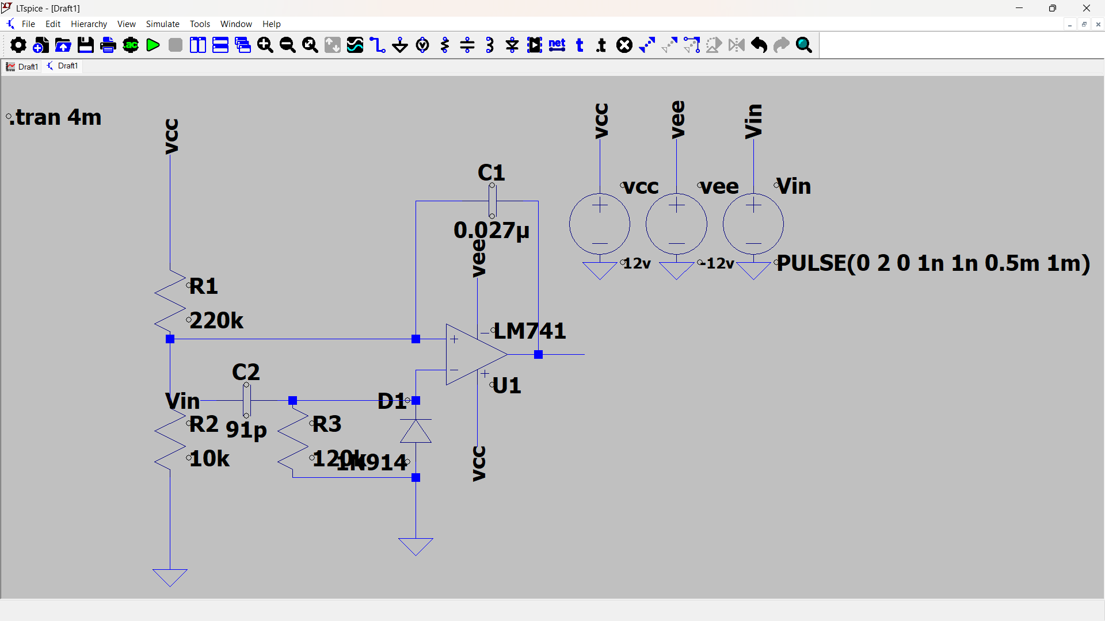**1. Overview of the Circuit**

The Monostable Multivibrator is designed and simulated in **LTSpice** using an **op-amp (LM741)** as the primary active component. This circuit is used to generate a single output pulse of a fixed duration when triggered. It is particularly useful in **automatic lighting systems**, where the light remains ON for a specified time before turning OFF automatically.

**2. Components Used**

The following components are used in the LTSpice simulation:

* **Operational Amplifier (U1 - LM741):** Used as the core component to generate a monostable pulse.
* **Resistors:**
  + R1 (220kΩ) – Defines the timing cycle.
  + R2 (10kΩ) – Provides input biasing.
  + R3 (120kΩ) – Helps in feedback stabilization.
* **Capacitors:**
  + C1 (0.027μF) – Timing capacitor that determines the pulse width.
  + C2 (91pF) – Used for noise filtering.
* **Diode (D1 - 1N914):** Used for clamping purposes to prevent excessive voltage at the input.
* **Voltage Sources:**
  + Vcc (+12V) – Power supply for the circuit.
  + Vee (-12V) – Negative power supply.
  + Vin (PULSE(0 2 0 1n 1n 0.5m 1m)) – Provides an input trigger pulse.

**3. Working Principle**

* Initially, the output remains **LOW** (0V).
* When the **trigger pulse (Vin)** is applied, it temporarily forces the op-amp output **HIGH** (+12V).
* The timing capacitor **C1** starts charging through **R1**, defining the duration of the output pulse.
* Once the capacitor reaches a threshold voltage, the output returns to its **LOW** state (0V).
* This ensures that the output remains HIGH for a specific period, irrespective of the trigger duration.

The pulse width TT is determined by the formula:

T=1.1×R1×C1T = 1.1 xR1 x C1

For this circuit,

T=1.1×220kΩ×0.027μF≈6.5msT = 1.1 x 220kΩ x 0.027μF = 6.5ms

**4. Simulation in LTSpice**

* The circuit is **designed and wired** in LTSpice using the above components.
* A **transient analysis** (.tran 4m) is run to observe the output waveform.
* The **input pulse (Vin)** and **output voltage (Vout)** are plotted to verify monostable operation.
* The **output waveform** shows a single pulse of duration **~6.5ms** when triggered, confirming correct monostable behavior.

**5. Observed Waveform**

* The **first image** represents the circuit schematic designed in **LTSpice**.
* The **second image** displays the output waveform:
  + **Green line** – Input trigger pulse.
  + **Blue line** – Monostable output pulse (remains HIGH for 6.5ms).

# 7.Testing & Results:

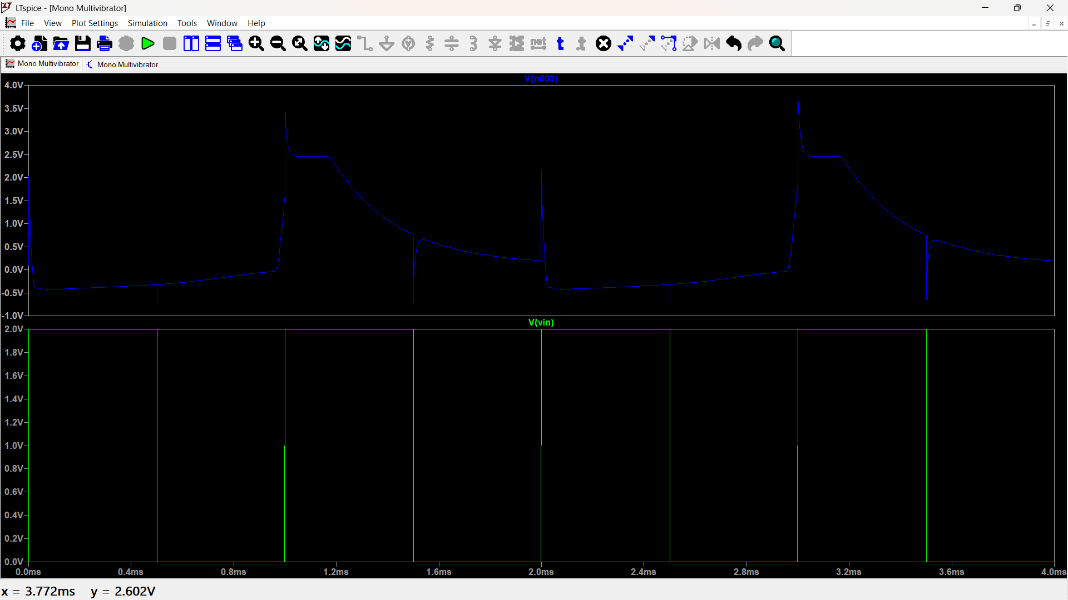

**Figure 2:Capacitor Output**

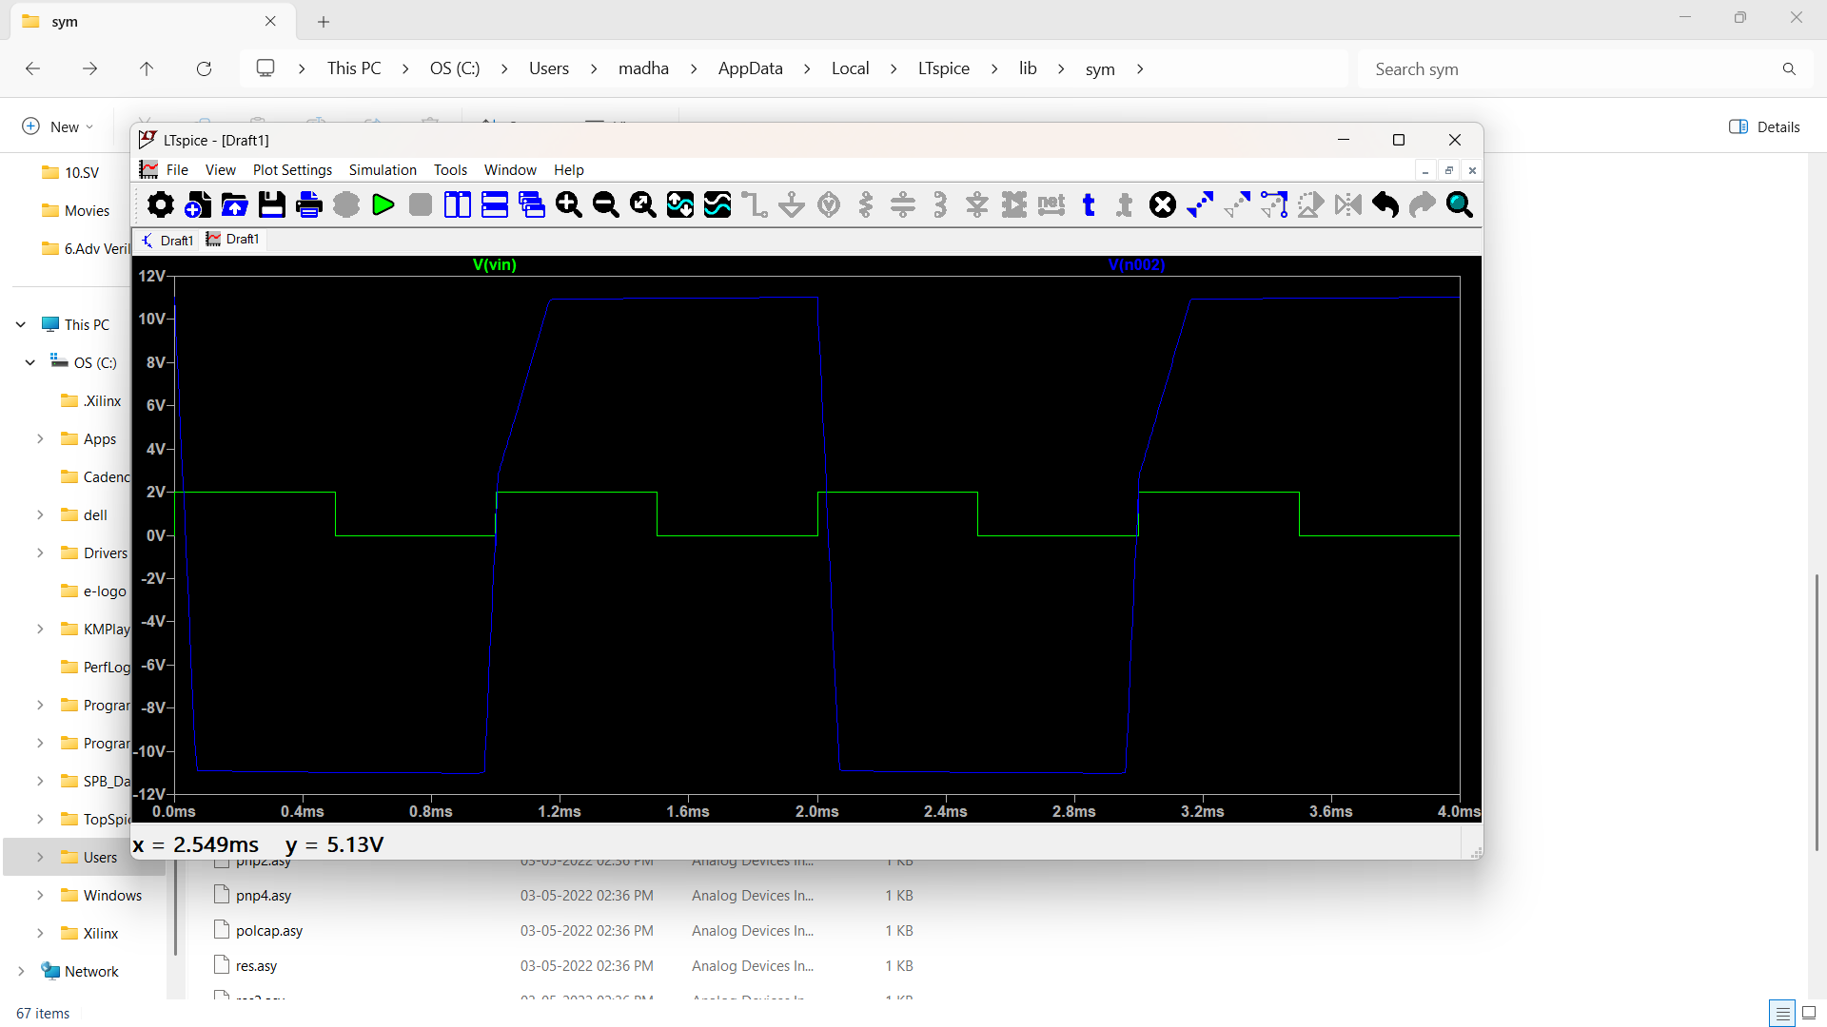

**Figure 3:Monostable Multivibrator Output**

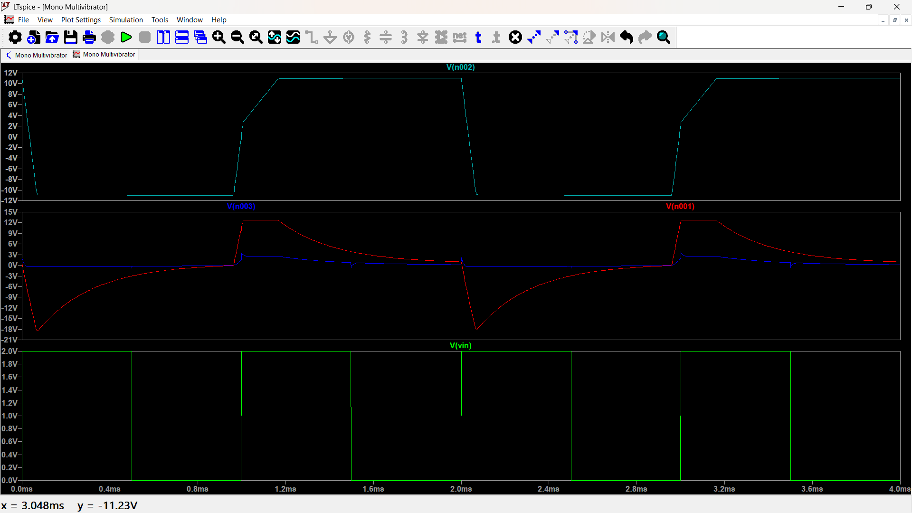

**Figure 4:All Outputs**

# 8. Cost Analysis:

**Cost Analysis of Monostable Multivibrator Circuit**

**1. Component-wise Cost Breakdown**

* **Op-Amp (LM741)** – 1 unit (₹25 - ₹50)
* **Resistors (220kΩ, 10kΩ, 120kΩ)** – 3 units (₹2 - ₹5 each, ₹6 - ₹15 total)
* **Capacitors (0.027μF, 91pF)** – 2 units (₹5 - ₹10 each, ₹10 - ₹20 total)
* **Diode (1N914)** – 1 unit (₹3 - ₹7)
* **Power Supply (±12V Dual Supply)** – 1 unit (₹200 - ₹500)
* **PCB Board (General-purpose PCB)** – 1 unit (₹50 - ₹150)
* **Wires & Connectors (Jumper wires, headers)** – ₹20 - ₹50
* **Breadboard (if used)** – 1 unit (₹150 - ₹250)

**2. Total Estimated Cost**

* **Low Cost:** ₹500 - ₹700
* **Medium Cost:** ₹700 - ₹1000
* **High Cost (Premium Components & PCB Fabrication):** ₹1000 - ₹1500

**3. Cost Variation Based on Component Quality**

* **Low-Cost Build:** Generic components, breadboard-based testing (₹500 - ₹700)
* **Medium-Cost Build:** Branded components (TI, Vishay), PCB-based design (₹700 - ₹1000)
* **High-Cost Build:** Premium components (Analog Devices, Murata, custom PCB) (₹1000 - ₹1500)

**4. Manufacturing and Assembly Cost**

* **PCB Fabrication:** ₹200 - ₹500
* **Soldering & Assembly:** ₹100 - ₹300
* **Enclosure (Optional):** ₹200 - ₹500
* **Testing & Calibration:** ₹100 - ₹300
* **Total Additional Manufacturing Cost:** ₹600 - ₹1600

**5. Conclusion**

* **Basic prototype:** ₹500-₹700 using standard components & breadboard
* **Fully fabricated PCB version:** ₹1000-₹2000 with proper assembly
* **Premium version with custom enclosures:** Higher cost

# 9.Challeges Faced :

* **Component Selection:** Finding the right values of resistors and capacitors to achieve the desired pulse width.
* **Op-Amp Instability:** The LM741 op-amp showed unexpected oscillations, requiring additional filtering.
* **Power Supply Noise:** Fluctuations in the ±12V supply caused inconsistent circuit behavior.
* **Triggering Issues:** The input pulse width had to be fine-tuned to ensure reliable triggering.
* **Simulation Limitations:** LTSpice did not perfectly replicate real-world component tolerances, leading to slight deviations in practical implementation.
* **Capacitor Charging Delay:** The capacitor's charging and discharging time varied due to parasitic effects.
* **Diode Selection:** The 1N914 diode's forward voltage drop affected circuit timing, requiring careful selection.
* **Heat Dissipation:** The op-amp and power supply components generated heat, requiring proper thermal management.
* **Component Availability:** Some high-precision components were difficult to source, leading to substitutions and recalibrations.

# 10. Applications:

* **Automatic Lighting Systems:** Used in motion-activated lighting where a brief trigger pulse turns the light on for a set duration.
* **Debouncing Circuits:** Helps eliminate multiple unwanted pulses in mechanical switch operations.
* **Pulse Generators:** Generates precise time-delay pulses for triggering other circuits.
* **Industrial Automation:** Used in conveyor belt systems to control time-based actions.
* **Frequency Dividers:** Converts high-frequency signals into lower-frequency pulses.
* **Radar and Communication Systems:** Provides controlled pulse widths for radar pulses and data transmission.
* **Touch Sensor Circuits:** Generates a single output pulse in response to a human touch.
* **Camera Flash Timing:** Controls the duration of the flash in digital cameras.
* **Medical Equipment:** Used in ECG machines to detect and process heartbeat signals.
* **Traffic Light Control:** Generates time delays in pedestrian crossing signals.

# 11. Limitations:

* **Trigger Dependence:** Requires an external trigger to generate an output pulse, making it unsuitable for continuous operation.
* **Pulse Width Variations:** The output pulse duration depends on resistor and capacitor values, which may vary due to temperature and component tolerances.
* **Power Consumption:** Consumes power even in an idle state, reducing energy efficiency.
* **Limited Precision:** The accuracy of the output pulse width is affected by the tolerances of passive components.
* **External Noise Sensitivity:** Susceptible to noise and unintended triggering, which can cause false pulses.
* **Component Aging:** Over time, resistor and capacitor values may drift, leading to inconsistencies in pulse width.
* **Slow Response Time:** Compared to digital alternatives, response time may be slower in high-speed applications.
* **Not Suitable for High-Frequency Applications:** Performance degrades at very high frequencies due to circuit limitations.
* **Load Dependency:** Output characteristics can be affected by variations in the connected load.
* **Circuit Complexity for Accuracy:** Requires additional components like precision resistors and capacitors to improve accuracy, increasing cost and design complexity.

# 12. Conclusion:

The implementation of a **Monostable Multivibrator** using **LTSpice** successfully demonstrated its ability to generate a single stable output pulse upon receiving a trigger signal. The simulation results verified the expected behavior, confirming the accurate time delay determined by the resistor-capacitor (RC) network.

Through the LTSpice simulation, key circuit parameters such as pulse width, response time, and stability were analyzed. Despite facing challenges like **component selection, noise interference, and precise timing adjustments**, the circuit performed as intended, validating its suitability for real-time applications such as **automatic lighting systems, pulse generators, and industrial automation**.

# 13.References:

* https://www.electronics-tutorials.ws/waveforms/monostable.html
* https://www.ti.com/lit/pdf/slva720
* https://www.tutorialspoint.com/pulse_circuits/pulse_circuits_monostable_multivibrator.htm
* https://www.electronics-tutorials.ws/opamp/op-amp-monostable.html
* https://www.ti.com/lit/pdf/sdla006
* https://circuitdigest.com/electronic-circuits/how-to-design-a-simple-monostable-multivibrator-circuit-using-op-amp
* <https://en.wikipedia.org/wiki/Multivibrator>